Building for 64-bit (AMD64/x64) architectures

Peter Wagner (aka wagnerp) & Simon coghlan (aka Smurf-IV) © 2018

Step 1) Open up Visual Studio and your project

Step 2) Right click your solution & point to **Configuration Manager…**

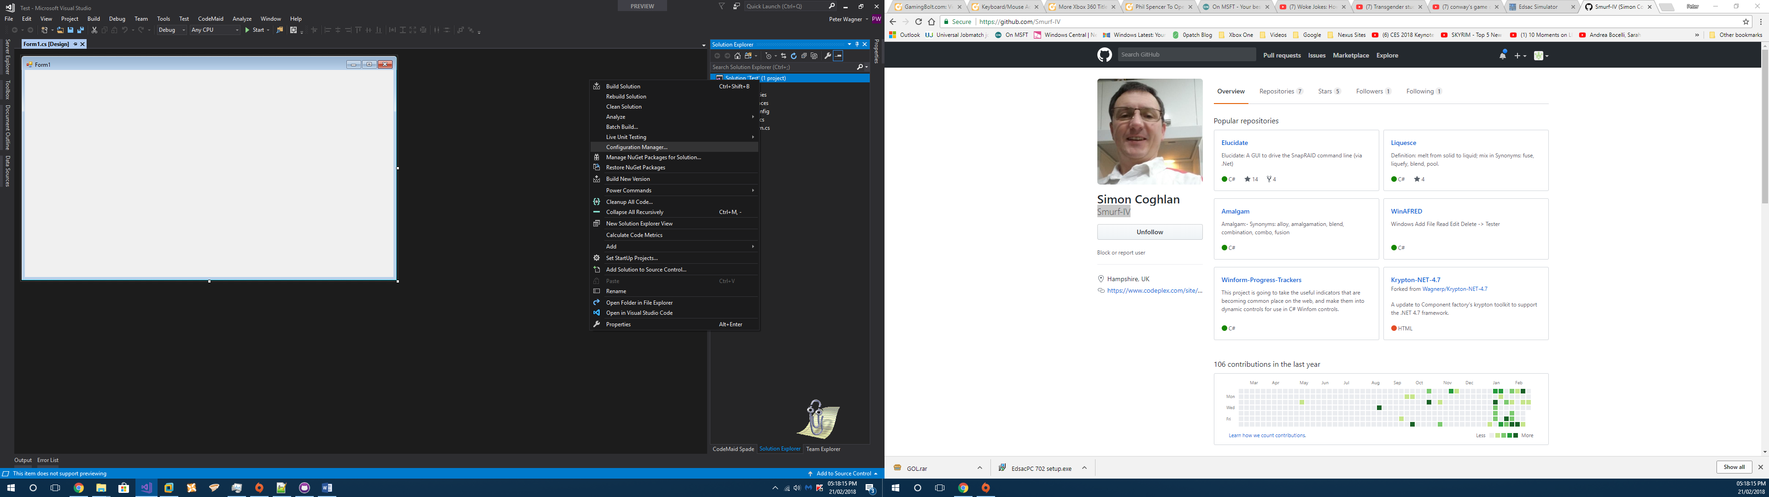

Once clicked, a new window should appear as follows

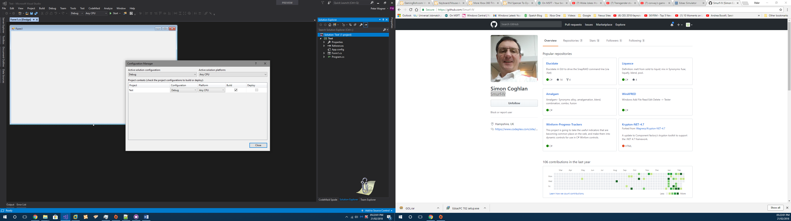

Step 3) In the **Active solution configuration** dropdown combo box, select <**New…>**

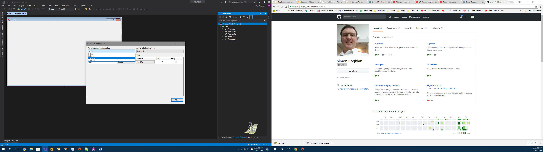

Once clicked, a new window should appear as follows

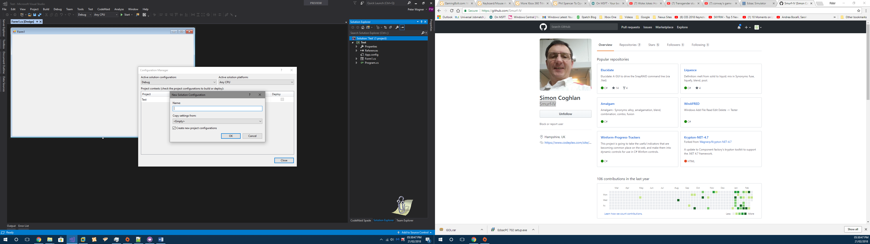

Step 4) In the **Name** field, type **Debug x64** and then click OK

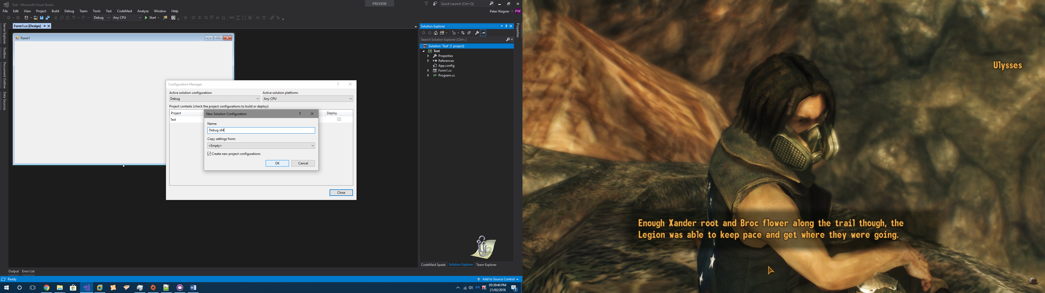

Repeat steps **3** & **4 for Release x64**

Step 5) Under the **Active solution platform** dropdown, select **<New…>**

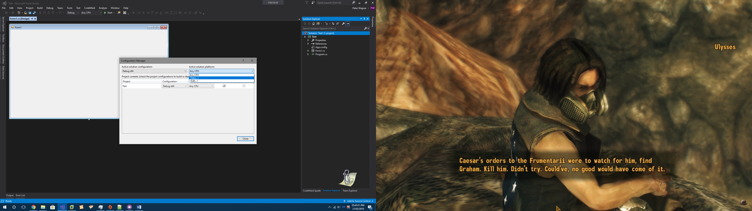

Once clicked, a new window should appear as follows

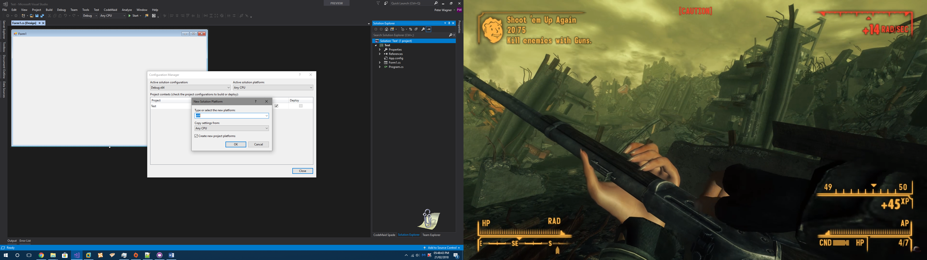

Click OK

Step 6) Your configuration should now look as follows

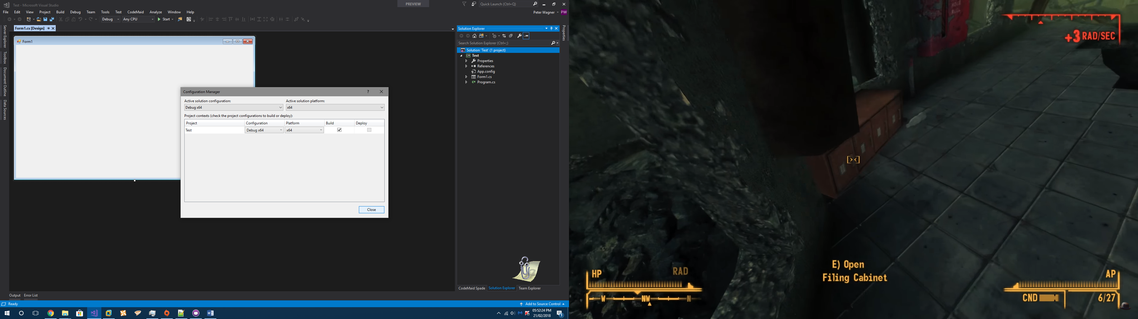

Now click **Close**

Step 7) Build your application as you would normally. Binaries will now be located in a new folder **<Path to code>\Bin\x64\Debug x64** or **<Path to code>\Bin\x64\Release x64**

Note to reader: Yes, you can use this guide to build 32-bit applications. Just replace **x64** with **x86**. Unfortunately, **ARM** is not supported.